`Topic 1
- How to distinguish between a population and a sample?
- How to distinguish between a parameter and a statistic?
- How to distinguish between descriptive statistics and inferential statistics?
- How to distinguish between qualitative data and quantitative data?
- How to classify data with respect to the four levels of measurement: nominal, ordinal, interval, and ratio?
- How data are collected: by doing an observational study, performing an experiment, using a simulation, or using a survey?
- How to create a sample using random sampling, simple random sampling, stratified sampling, cluster sampling, and systematic sampling?
- How to identify a biased sample?
Topic 2
- Sample batting averages for baseball players from two opposing teams are listed. Find the mean, median, range, variance, and standard deviation of each data set.
Team A: 0.295 0.310 0.325 0.272 0.256 0.297 0.320 0.384 0.235
Team B: 0.285 0.305 0.315 0.270 0.292 0.330 0.335 0.268 0.290
- The amounts of caffeine in a sample of five-ounce servings of brewed coffee are shown in the histogram. Make a frequency distribution for the data. Then use the table to estimate the sample mean and the sample standard deviation of the data set.
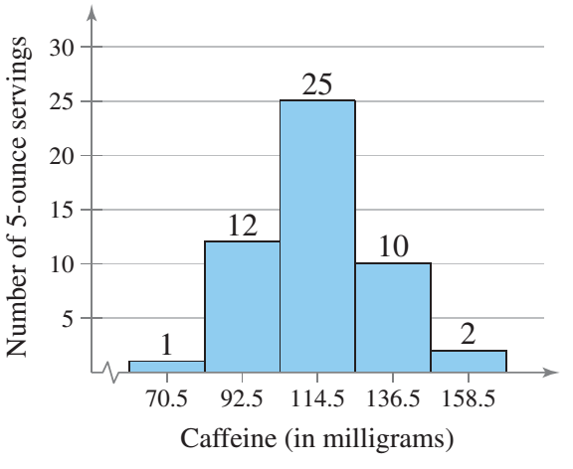
- The number of gallons of water consumed per day by a small village are listed. Make a frequency distribution (using five classes) for the data set. Then approximate the population mean and the population standard deviation of the data set.
167 180 192 173 145 151 174 175 178 160
195 224 244 146 162 146 177 163 149 188
- The estimated distribution (in millions) of the U.S. population by age for the year 2015 is shown in the pie chart. Make a frequency distribution for the data. Then use the table to estimate the sample mean and the sample standard deviation of the data set. Use 70 as the midpoint for “65 years and over.”
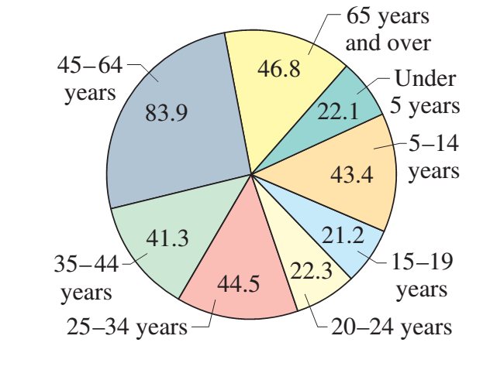

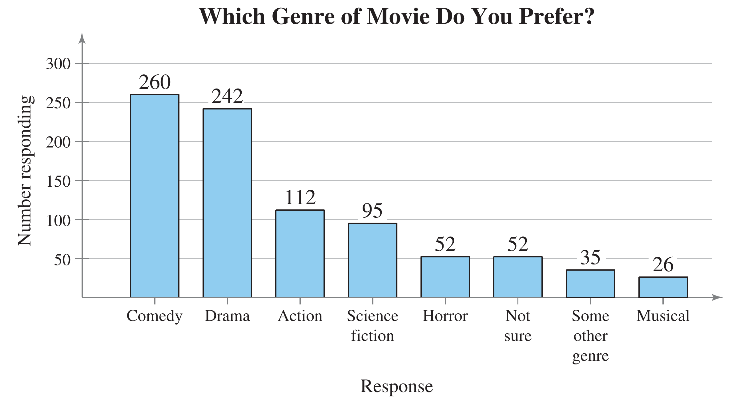
- Find the probability of randomly selecting an adult from the sample who prefers an action movie or a horror movie.
- Find the probability of randomly selecting an adult from the sample who prefers a drama or a musical.
- Find the probability of randomly selecting an adult from the sample who does not prefer a comedy.
- Find the probability of randomly selecting an adult from the sample who does not prefer a science fiction movie or an action movie.
- A survey was conducted to measure the heights of U.S. women. In the survey, respondents were grouped by age. In the 20–29 age group, the heights were normally distributed, with a mean of 64.3 inches and a standard deviation of 2.6 inches. A study participant is randomly selected.
(a) Find the probability that her height is less than 56.5 inches.
(b) Find the probability that her height is between 61 and 67 inches.
(c) Find the probability that her height is more than 70.5 inches.
7. A cheese processing company wants to estimate the mean cholesterol content of all one-ounce servings of cheese. The estimate must be within 0.5 milligram of the population mean.
(a) Determine the minimum required sample size to construct a 95% confidence interval for the population mean. Assume the population standard deviation is 2.8 milligrams.
(b) Repeat part (a) using a 99% confidence interval.
(c) Which level of confidence requires a larger sample size? Explain.
8. Determine the minimum required sample size if you want to be 99% confident that the sample mean is within two units of the population mean given Assume the population is normally distributed.
9. A random sample of forty-eight 200-meter swims has a mean time of 3.12 minutes and a standard deviation of 0.09 minute. Construct a 95% confidence interval for the population mean time. Interpret the results.

Topic 3
- A random sample of 50 medical school applicants at a university has a mean raw score of 31 with a standard deviation of 2.5 on the multiple-choice portions of the Medical College Admission Test (MCAT). A student says that the mean raw score for the school’s applicants is more than 30. At is there enough evidence to support the student’s claim at α=0.05?
- A manufacturer of sprinkler systems designed for fire protection claims that the average activating temperature is at least 135 F. To test this claim, you randomly select a sample of 32 systems and find the
mean activation temperature to be 133 F with a standard deviation of 3.3 F. At do you have enough evidence to reject the manufacturer’s claim at α=0.05?
- The Internal Revenue Service claims that the mean wait time for callers during a recent tax filing season was at most 7 minutes. A random sample of 11 callers has a mean wait time of 8.7 minutes and a
standard deviation of 2.7 minutes. Is there enough evidence to reject the claim at α=0.05.
- A medical researcher says that less than 25% of U.S. adults are smokers. In a random sample of 200 U.S. adults, 18.5% say that they are smokers. At α=0.05 is there enough evidence to reject the researcher’s
claim?
- A humane society claims that less than 35% of U.S. households own a dog. In a random sample of 400 U.S. households, 156 say they own a dog. At α=0.05 is there enough evidence to support the society’s claim?
- An auto manufacturer believes that the variance of the gas mileages of its hybrid vehicles is 1.0. You work for an energy conservation agency and want to test this claim. You find that a
random sample of the gas mileages of 25 of the manufacturer’s hybrid vehicles has a variance of 1.65. At α=0.05 do you have enough evidence to reject the manufacturer’s claim?
Topic 4
- To compare the braking distances for two types of tires, a safety engineer conducts 35 braking tests for each type. The results of the tests are shown in the figure. At α=0.10 can the engineer support the claim
that the mean braking distances are different for the two types of tires?
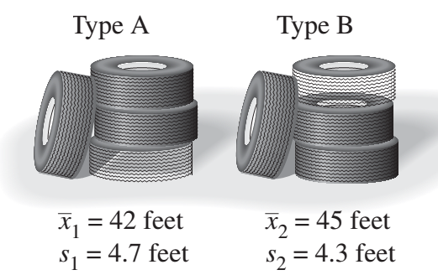
- A real estate agency says that the average home sales price in Dallas, Texas is the same as in Austin, Texas. The average home sales price for 35 homes in Dallas is $240,993 and the standard deviation is $25,875. The average home sales price for 35 homes in Austin is $249,237 and the standard
deviation is $27,110. At α=0.1 is there enough evidence to reject the agency’s claim?
- In low-speed crash tests, the mean bumper repair cost of 6 randomly selected mini cars is $1621 with a standard deviation of $493. In similar tests of 16 randomly selected midsize cars, the mean bumper
repair cost is $1895, with a standard deviation of $648. At α=0.1 can you conclude that the mean bumper repair cost is less for mini cars than for midsize cars? Assume the population variances are equal.
- The tensile strength of a metal is a measure of its ability to resist tearing when it is pulled lengthwise. A new experimental type of treatment produced steel bars with the following tensile strengths (in newtons per square millimeter).
Experimental Method:
391 383 333 378 368 401 339 376 366 348
The old method produced steel bars with the following tensile strengths (in newtons per square millimeter).
Old Method:
362 382 368 398 381 391 400 410 396 411 385 385 395
At α=0.1 does the new treatment make a difference in the tensile strength of steel bars? Assume the population variances are equal.
- A teacher claims that a grammar seminar will help students reduce the number of grammatical errors they make when writing a 1000-word essay. The table shows the number of grammatical errors made by seven students before participating in the seminar and after participating in the seminar. At α=0.1 is there enough evidence to conclude that the seminar reduced the number of errors?
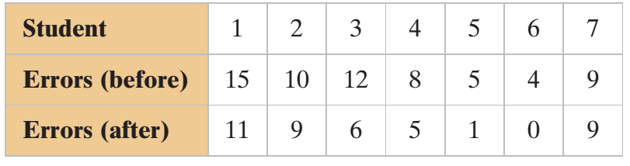
- A medical research team conducted a study to test the effect of a cholesterol-reducing medication. At the end of the study, the researchers found that of the 4700 randomly selected subjects who took the medication, 301 died of heart disease. Of the 4300 randomly selected subjects who took a placebo,
357 died of heart disease. At α=0.1 can you support the claim that the death rate due to heart disease is lower for those who took the medication than for those who took the placebo?

Topic 5
- A researcher conducts a study to determine whether there is a linear relationship between a person’s height (in inches) and pulse rate (in beats per minute). The data are shown in the following table. Display the data in a scatter plot and describe the type of correlation.
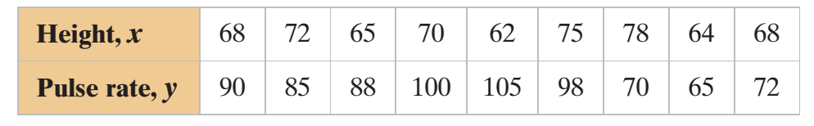
- Does there appear to be a linear correlation? If so, interpret the correlation
in the context of the data.
- Calculate the correlation coefficient.
- Is the correlationcoefficient significant at α=0.05?
- Find the equation of the regression line for the pulse rate.
- Find the coefficient of determination. What does this tell you about the explained variation of the data about the regression line? About the unexplained variation?

Topic 5
- Is the length of unemployment related to the type of industry? A random sample of unemployed workers from three different sectors yielded the following data. At α= 0.05 level of significance, are the two categories dependent?
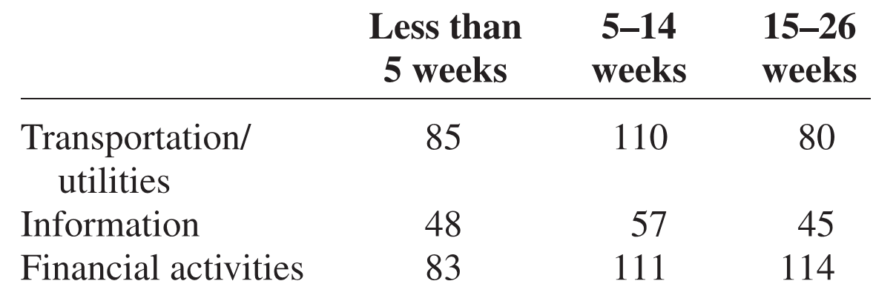

- Americans appear to be eating healthier. Between 1970 and 2007 the per capita consumption of broccoli increased 1000% from 0.5 to 5.5 pounds. A nutritionist followed a group of people randomly assigned to one of three groups and noted their monthly broccoli intake (in pounds). At α= 0.05, is there a difference in means?
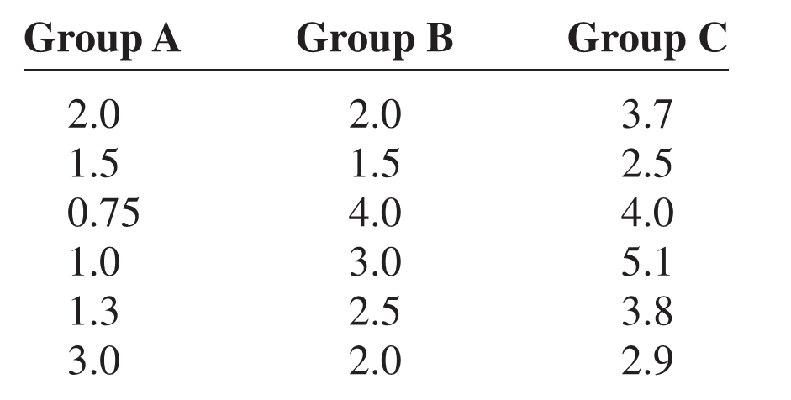
- A contractor wishes to see whether there is a difference in the time (in days) it takes two subcontractors to build three different types of homes. At α= 0.05, analyze the data shown here, using a two-way ANOVA. See below for raw data.
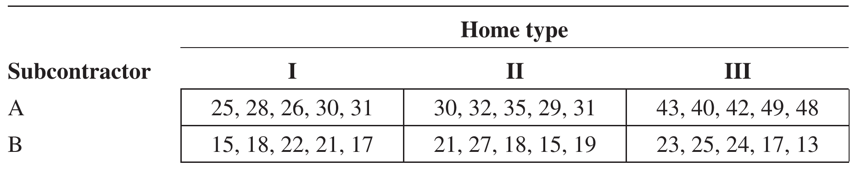

Topic 6
- A statistics professor wants to investigate the relationship between a student’s midterm examination
score and the score on the final. Eight students were randomly selected, and their scores on the two examinations are noted. At α= 0.10 level of significance, is there sufficient evidence to conclude that there is a difference in scores?
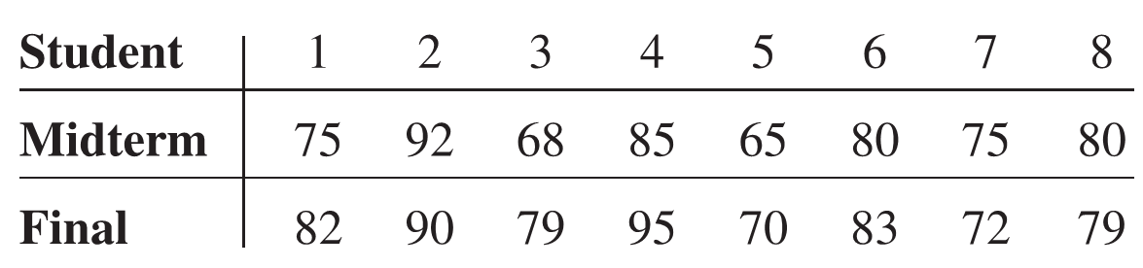
- How big is a teaspoon? Many cookie recipes call for a teaspoon of dough to be dropped for
each cookie. Eight randomly selected volunteer bakers baked a standard chocolate chip cookie recipe, making the cookies their usual “teaspoon” size. The number of cookies was recorded for each baker. Each volunteer was then given a new device that automatically dispenses a teaspoon of dough and then was asked to bake another batch of cookies, counting the results. At a 0.10, is there a difference in the number of cookies per baker?
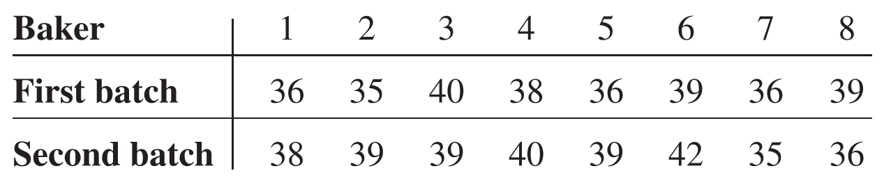

- The following are scores from a technology proficiency test required of all new incoming students at a particular college. Use the Wilcoxon rank sum test to see if there is a difference in scores between randomly selected freshmen and randomly selected transfer students at the 0.05 level of significance.
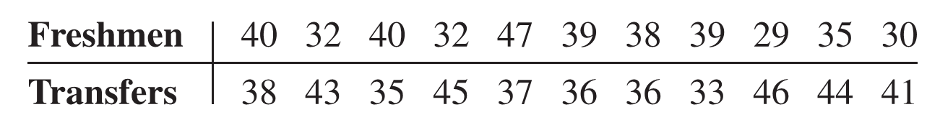
- Test the hypothesis that the randomly selected assessed values have changed between 2006 and 2010. Use α= 0.05. Do you think land values in a large city would be normally distributed?
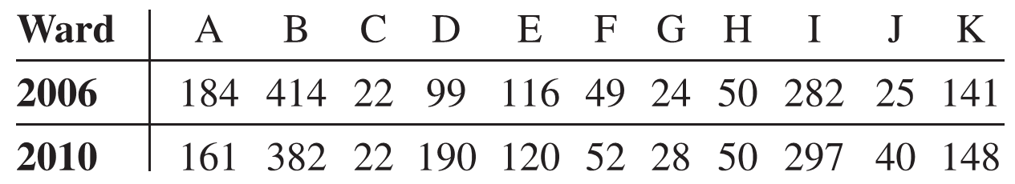
- A recent study recorded the number of job offers received by randomly selected, newly graduated chemical engineers at three colleges. The data are shown here. At α= 0.05, is there a difference in the average number of job offers received by the graduates at the three colleges?
